OSPF Routing Configuration
Disclaimer: this was the second practical exercise done in class. This activity belongs to Eduvos – I just wanted to show the skills learnt throughout my degree.

  - Step 1: Add and Connect the Devices
DEVICES: | DEFAULT NAME: | NEW NAME:
PT-Empty Router | Router0 | R0
 | Router1 | R1
 | Router2 | R2
2960-24TT Switch | Switch0 | S0
 | Switch1 | S1
 | Switch2 | S2
PC-PT PC | PC0 | PC0
 | PC1 | PC1
 | PC2 | PC2
 | PC3 | PC3
 | PC4 | PC4
 | PC5 | PC5

Step 2: Add Ports in Routers
Steps:
- Switch off the device.
- Add the ports.
- Switch on the devices.

Router0 Before:
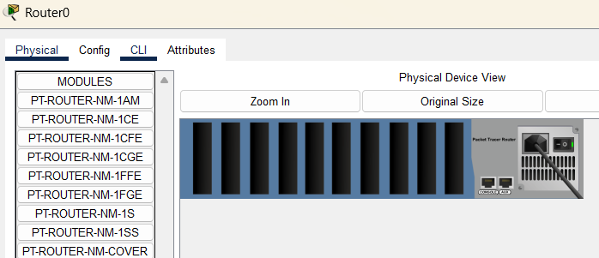

Router0 After:
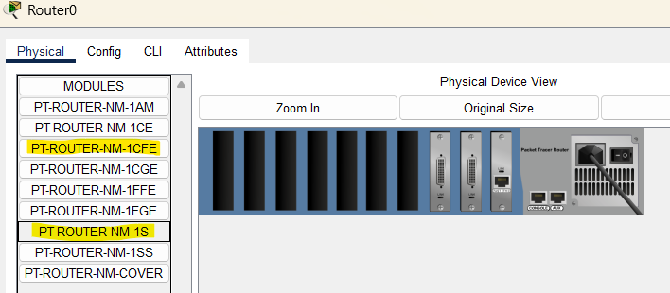

Router1 Before:
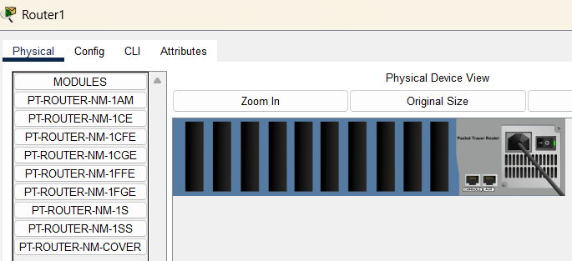

Router1 After:
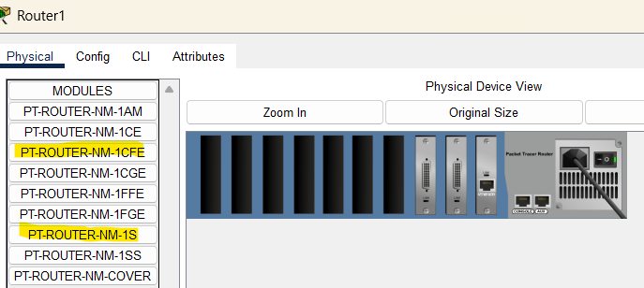

Router2 Before:
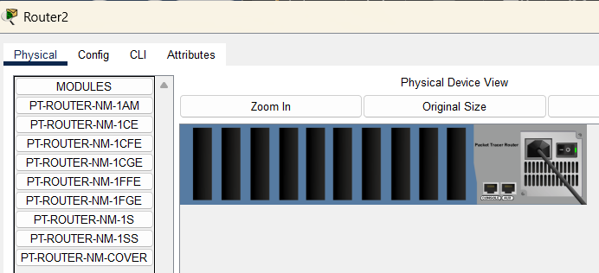

Router2 After:
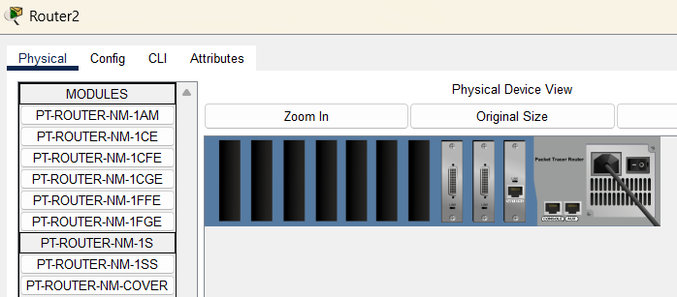

Step 3: Connect the Devices
Use a serial DCE for the routers and a copper straight-through cable was used to connect the other devices.

- Router0 (Serial1/0) to Router1 (Serial1/0)
- Router1 (Serial2/0) to Router2 (Serial1/0)
- Router0 (Serial2/0) to Router2 (Serial2/0)

- Switch0 (FastEthernert0/1) to PC0 (FastEthernert0)
- Switch0 (FastEthernert0/2) to PC1 (FastEthernert0)
- Switch1 (FastEthernert0/1) to PC2 (FastEthernert0)
- Switch1 (FastEthernert0/2) to PC3 (FastEthernert0)
- Switch2 (FastEthernert0/1) to PC4 (FastEthernert0)
- Switch2 (FastEthernert0/2) to PC5 (FastEthernert0)

- Router0 (FastEthernet0/0) to Switch0 (FastEthernert0/3)
- Router1 (FastEthernet0/0) to Switch1 (FastEthernert0/3)
- Router2 (FastEthernet0/0) to Switch2 (FastEthernert0/3)

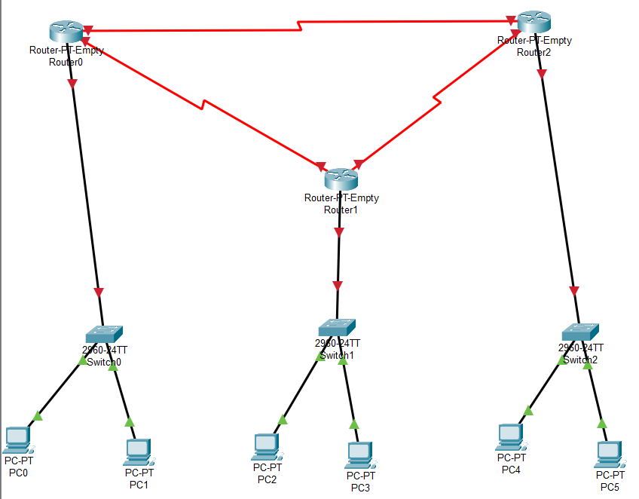

  - Step 4: Assign IP addresses to the PCs
PC > Desktop > IP Configuration > Enter IPv4 details

PC0:
- IPv4 Address: 192.168.1.2
- Subnet Mask: 255.255.255.0
- Default Gateway: 192.168.1.1

Screenshot of Output
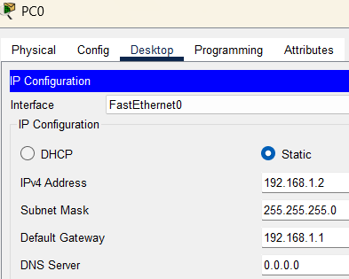

PC1:
- IPv4 Address: 192.168.1.3
- Subnet Mask: 255.255.255.0
- Default Gateway: 192.168.1.1

Screenshot of Output
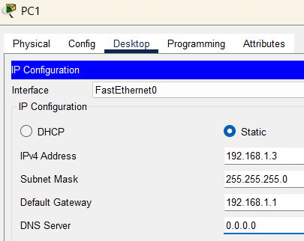

PC2:
- IPv4 Address: 192.168.2.2
- Subnet Mask: 255.255.255.0
- Default Gateway: 192.168.2.1
Screenshot of Output
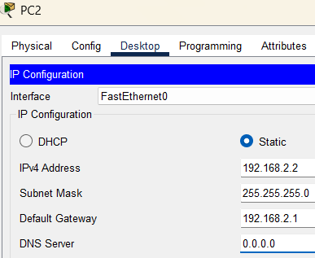

PC3:
- IPv4 Address: 192.168.2.3
- Subnet Mask: 255.255.255.0
- Default Gateway: 192.168.2.1

Screenshot of Output
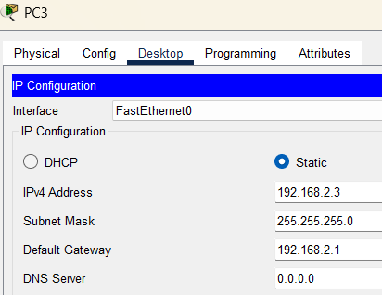

PC4:
- IPv4 Address: 192.168.3.2
- Subnet Mask: 255.255.255.0
- Default Gateway: 192.168.3.1

Screenshot of Output
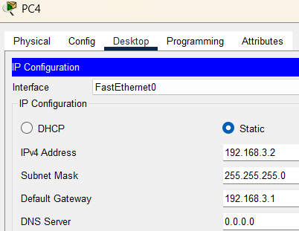

PC5:
- IPv4 Address: 192.168.3.3
- Subnet Mask: 255.255.255.0
- Default Gateway: 192.168.3.1

Screenshot of Output
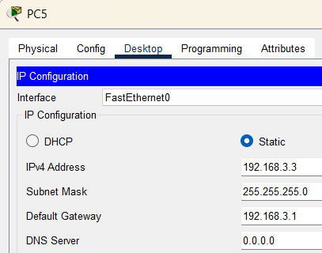
  - Step 5: Assign IP Addresses to the cable interfaces
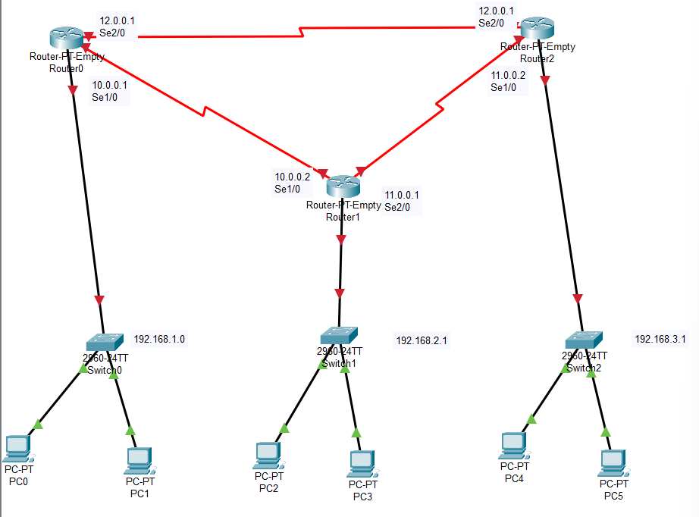

  - Step 6: Change the Interfaces
Router0 to Router1:
These configurations were done in the Router1 CLI.

Commands Used
Router> en
Router# config
Router(config)# interface serial1/0
Router(config-if)# no shutdown
Router(config-if)# end

Screenshot of Output
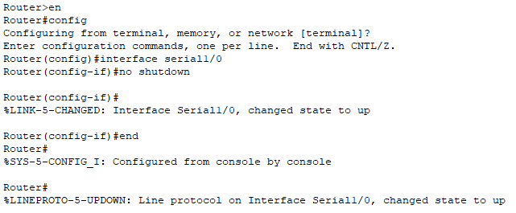

Router1 to Router2:
These configurations were done in the Router2 CLI.
Commands Used
Router> en
Router# config
Router(config)# interface serial1/0
Router(config-if)# no shutdown
Router(config-if)# end

Screenshot of Output
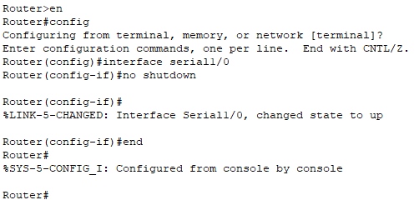

Router0 to Router2:
These configurations were done in the Router2 CLI.
Commands Used
Router> en
Router# config
Router(config)# interface serial2/0
Router(config-if)# no shutdown
Router(config-if)# end

Screenshot of Output
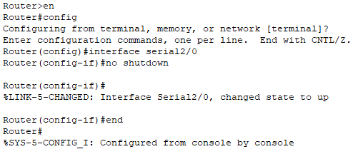

Router1 to Switch1:
These configurations were done in the Router1 CLI.
Commands Used
Router> en
Router# config
Router(config)# interface FastEthernet0/0
Router(config-if)# no shutdown
Router(config-if)# end

Screenshot of Output
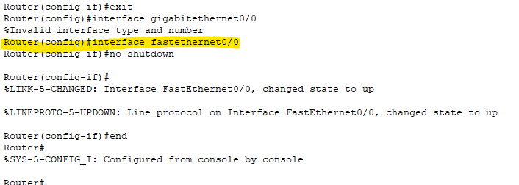

Router1 to Switch1:
These configurations were done in the Router2 CLI.
Commands Used
Router> en
Router# config
Router(config)# interface FastEthernet0/0
Router(config-if)# no shutdown
Router(config-if)# end

Screenshot of Output
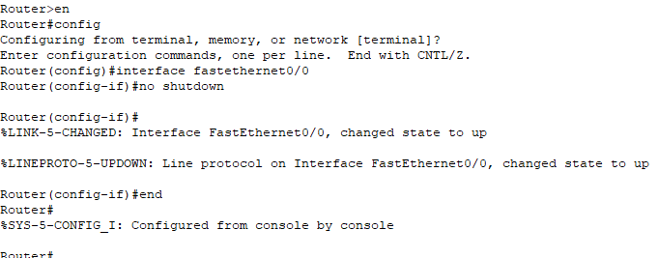

  - Step 7: Configure the Interfaces in Router0
Commands Used
R0> en
R0# config
R0(config)# interface FastEthernet0/0
R0(config-if)# ip address 192.168.1.1 255.255.255.0
R0(config-if)# no shutdown
R0(config-if)# exit

R0(config)# interfaceserial1/0
R0(config-if)# ip address 10.0.0.1 255.0.0.0
R0(config-if)# clock rate 64000
R0(config-if)# no shutdown
R0(config-if)# exit

R0(config)# interfaceserial2/0
R0(config-if)# ip address 12.0.0.1 255.0.0.0
R0(config-if)# clock rate 64000
R0(config-if)# no shutdown
R0(config-if)# exit

Screenshot of Output
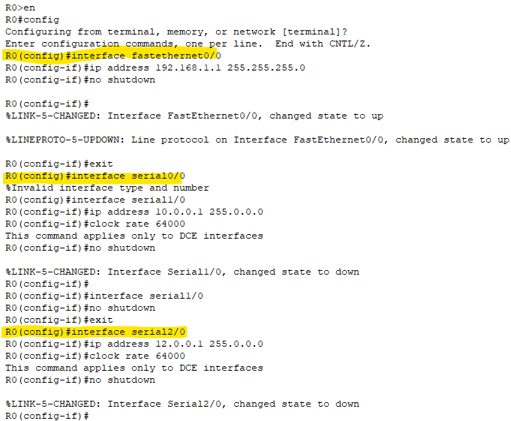

  - Step 8: Configure the OSPF in Router0
Commands Used
Router0> en
Router0# config
Router0(config)# router ospf 1
Router0(config-router)# network 192.168.1.0 0.0.0.255 area 0
Router0(config-router)# network 10.0.0.0 0.255.255.255 area 0
Router0(config-router)# network 12.0.0.0 0.255.255.255 area 0

Screenshot of Output
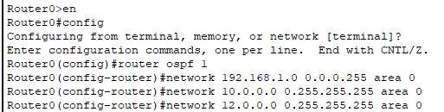

  - Step 9: Configure the Interfaces in Router1
Commands Used
Router> en
Router# config
Router(config)# interface FastEthernet0/0
Router(config-if)# ip address 192.168.2.1 255.255.255.0
Router(config-if)# no shutdown
Router(config-if)# exit

Router(config)# interface serial2/0
Router(config-if)# ip address 11.0.0.1 255.0.0.0
Router(config-if)# clock rate 64000
Router(config-if)# no shutdown
Router(config-if)# exit

Screenshot of Output
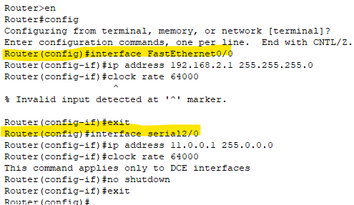
  - Step 10: Configure the OSPF in Router1
Commands Used
Router> en
Router# config
Router(config)# router ospf 1
Router(config-router)# network 192.168.2.0 0.0.0.255 area 0
Router(config-router)# network 10.0.0.0 0.255.255.255 area 0
Router(config-router)# network 11.0.0.0 0.255.255.255 area 0
Router(config-router)# exit

Screenshot of Output
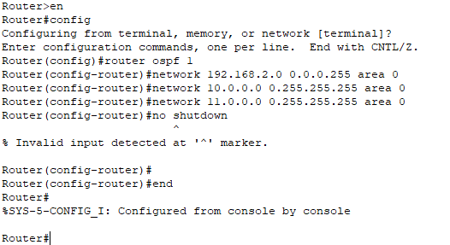

  - Step 11: Configure the interfaces in Router2
Commands Used
Router> en
Router# config
Router(config)# interface FastEthernet0/0
Router(config-if)# ip address 192.168.3.1 255.255.255.0
Router(config-if)# no shutdown
Router(config-if)# exit

Router(config)# interface serial2/0
Router(config-if)# ip address 12.0.0.1 255.0.0.0
Router(config-if)# clock rate 64000
Router(config-if)# no shutdown
Router(config-if)# exit

Screenshot of Output
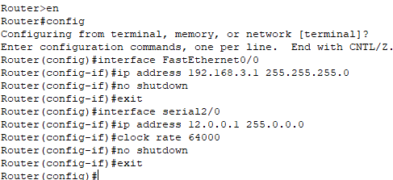

  - Step 12: Configure the OSPF in Router2
Commands Used
Router> en
Router# config
Router(config)# router ospf 1
Router(config-router)# network 192.168.3.0 0.0.0.255 area 0
Router(config-router)# network 10.0.0.0 0.255.255.255 area 0
Router(config-router)# network 11.0.0.0 0.255.255.255 area 0
Router(config-router)# exit

Screenshot of Output
